LESSON OVERVIEW
Toolkit Topic: Industrial Revolution
Lesson Title: Global Warming since the Industrial Revolution (Current events)
Subject/Grade Level: Social Studies/5th Grade
Lesson Duration: One class period
ESSENTIAL QUESTIONS
Essential Question(s) for Toolkit: Would your life be better or worse if the Industrial Revolution never happened? Why or why not? Keep the way of living, environmental effects, and laws put in place in mind.
Essential Question(s) for Lesson: What effect has the greenhouse gases had on the earth since the industrial revolution?
OBJECTIVES  - Students will be able to use their knowledge of the greenhouse effect to examine the problems that have been happening since the Industrial Revolution.  - Students will be able to use their knowledge of greenhouse gases to make a claim about if our environment would be different if the Industrial Revolution never happened. | STANDARDS  - A.8.1 Identify environmental issue* questions that can be investigated using resources and equipment available (see SC Inquiry; LA Research)  - B.8.15 Analyze how people impact their environment through resource use
ASSESSMENTS
- I will formatively assess the students after they give their definitions of the vocab words. If the students do not have the correct understanding, I will lead them to a better understanding.
- The students will all be asked to turn in a sheet answering the questions that are given with the articles.
- The students will be assessed by their answer of the lesson closing. If they are able to answer this question in a discussion with evidence, I know my objective is complete.

DIFFERENTIATION
I can pair students that may have a harder time with the reading with better readers to help struggling students.
LESSON CONTENT OUTLINE
Lesson Opening | I will ask the students where they think pollution comes from. This will then lead into the first activity to define pollution and other vocabulary words.
Learning Activities | 1) I will ask the students to define the following words with their neighbor: pollution, fossil fuels, greenhouse effect, and greenhouse gases. After they discuss their own definitions with their partner, we will discuss the definitions as a class. I will write their definitions on the board. [5-10 minutes]  2) I will show the following video: https://www.youtube.com/watch?v=VYMjSule0Bw [2 minutes]  3) I will ask the students to, with their partner draw a drawing using the earth, sunlight, infrared radiation, and energy trapped by greenhouse gases. I will then have one student come up to the board to draw their picture and have another student in the class describe their drawing. If it was not right, I will provide a picture like the below. [10 minutes]  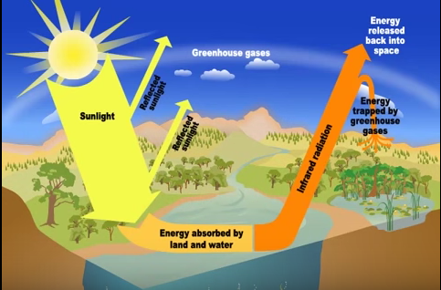  4) I will show the following graphs: https://www3.epa.gov/climatechange/students/scientists/pieces.html  I will explain that carbon dioxide is an example of a greenhouse gas and I will ask the students how the time period correlates with the increase of carbon dioxide emissions. I will also ask why the carbon dioxide emissions continue to exponentially climb. [5 minutes]  5) The students will next be separated into groups of 5. Each group will read two articles from the following website: https://www3.epa.gov/climatechange/students/impacts/signs/index.html (higher temperatures and more droughts; wilder weather and changing rain and snow patterns; less snowpack and melting glaciers; shrinking sea ice and warmer oceans; and increased ocean acidity and rising sea level) These articles will be printed out for the group members. As a group, they will answer the following questions: Why is this happening?; What will happen if this continues?; What is effected and how is effected?; and What can we do to fix it? (List 5 solutions). [20 minutes]  6) After given about 20 minutes to read the articles and answer the questions, each group will present their findings. [10 minutes]
Lesson Closing | I will wrap up the lesson by asking the students to create an exit slip that includes if they think our environment would be different if the Industrial Revolution never happened and how it would be.

MATERIALS/RESOURCES/TECHNOLOGY
A projector is need to show the website.
Links:
- https://www.youtube.com/watch?v=VYMjSule0Bw
- https://www3.epa.gov/climatechange/students/scientists/pieces.html
- https://www3.epa.gov/climatechange/students/impacts/signs/index.html

