LESSON OVERVIEW
Toolkit Topic: Industrial Revolution
Lesson Title: Child Labor Laws (Interdisciplinary topics- History and Writing)
Subject/Grade Level: Social Studies/5th Grade
Lesson Duration: One hour lesson
ESSENTIAL QUESTIONS
Essential Question(s) for Toolkit: Would your life be better or worse if the Industrial Revolution never happened? Why or why not? Keep the way of living, environmental effects, and laws put in place in mind.
Essential Question(s) for Lesson: Why were the child labor laws put in place?
OBJECTIVES  - Students will interpret the hardships that the children of the Industrial Revolution faced through examining pictures and articles from the time period.  - Students will create a claim about child labor or child labor laws and justify this claim with evidence from the pictures and articles given.  - Students will create a paragraph that includes a topic sentence that is their claim and supporting sentences that are their pieces of evidence. | STANDARDS  - Wisconsin Social Studies: History B.8.12  - Wisconsin Social Studies: History B.8.5  - Wisconsin Social Studies: History B.8.7  - Common Core State Standard: English Language Arts CCSS.ELA-LITERACY.W.5.1
ASSESSMENTS
- Students’ participation will be assessed during the discussion. The worksheet will also be assessed. I will use this worksheet to see if they are able to see an artifact and analyze child labor.
- Students’ paragraph will be assessed to see if they are able to make a claim and back the claim up with evidence. It will also be assessed grammatically.
DIFFERENTIATION
Students could be given different roles during the discussion based on their specific needs.
LESSON CONTENT OUTLINE
Lesson Opening | Since this is not their first lesson on the Industrial Revolution, I will connect to prior knowledge by asking them to do a partner share. With their partner, they will come up with a question about what they have learned so far. They will then share their questions with the class and I will encourage other students to answer the question. If other students cannot answer the questions, I will. [5 minutes]
Learning Activities | 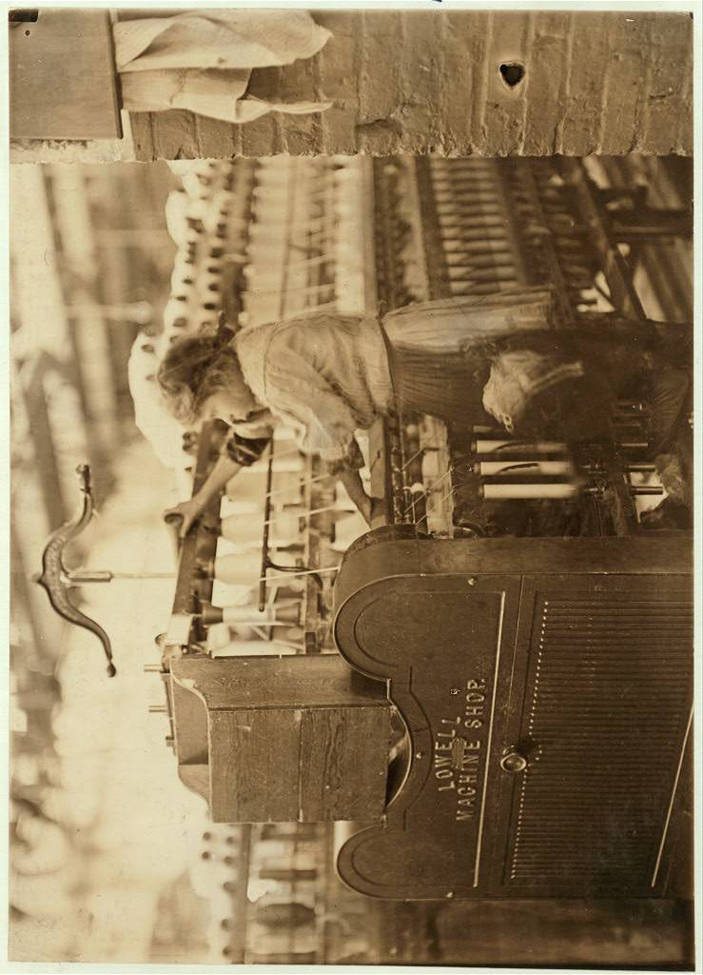  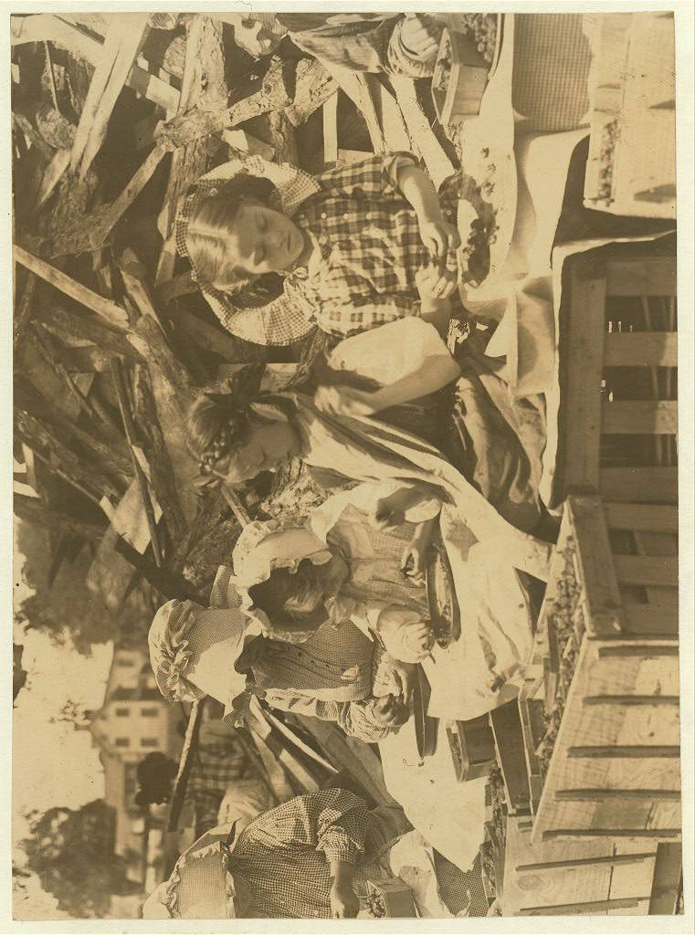  - After my lesson opening, the students will be put in groups of three or four. Each group will be given a worksheet to complete as a group (on page 7) as I present the following pictures on projector. I will also have the following pictures printed out for each group. Students should discuss answers as a group. I will first model how to fill the worksheet out with the first picture then they will finish the worksheet on their own. I will be walking around the classroom to ensure everyone is participating in the group and to assist with any questions. [15 minutes]  1)  2)  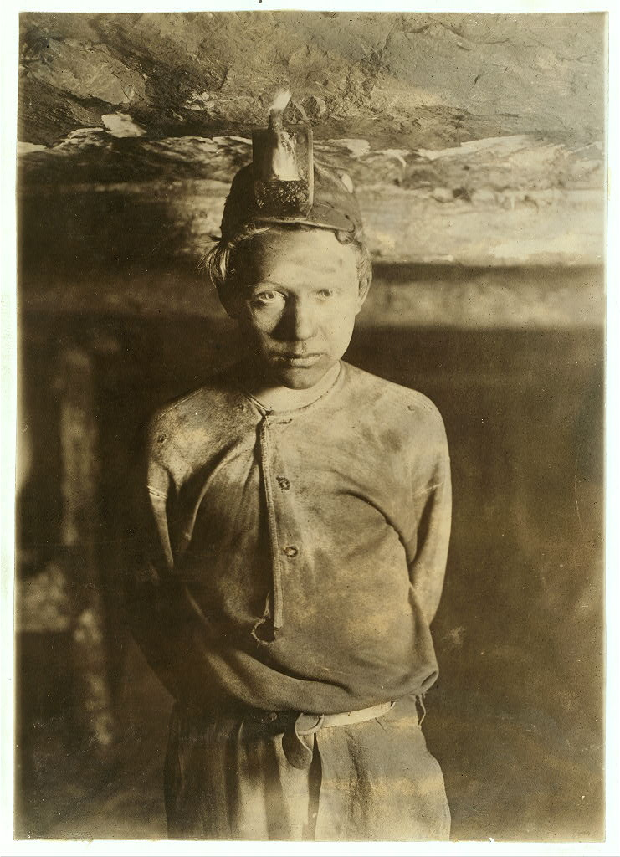  3)  4)  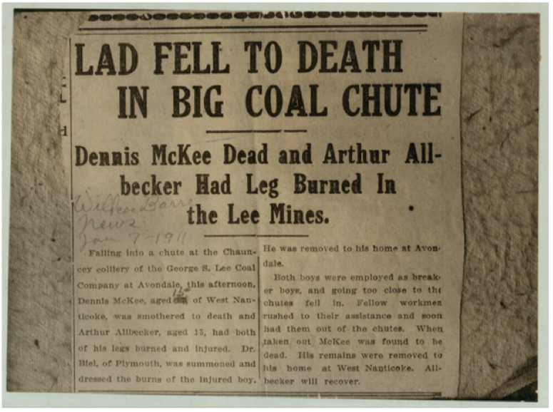  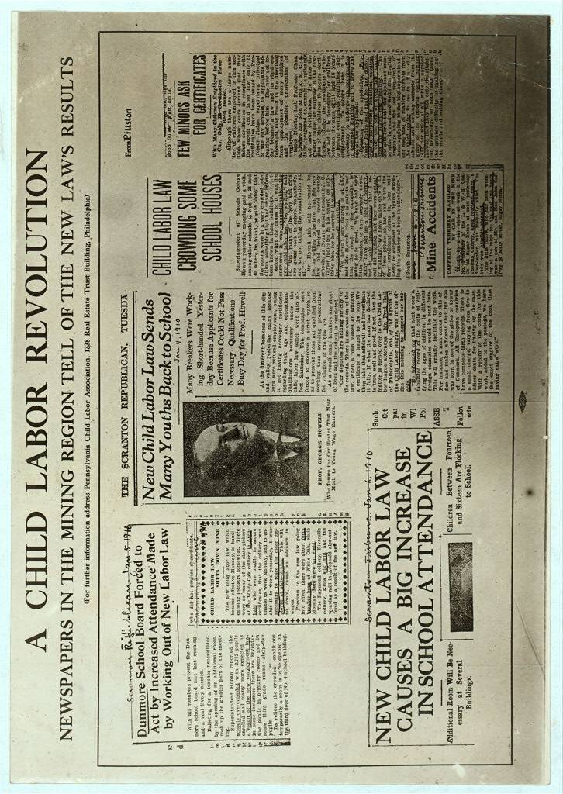  5)  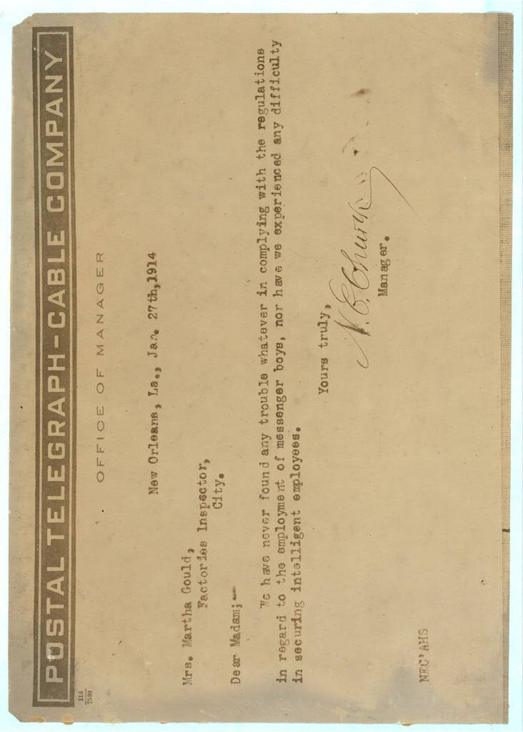  6)  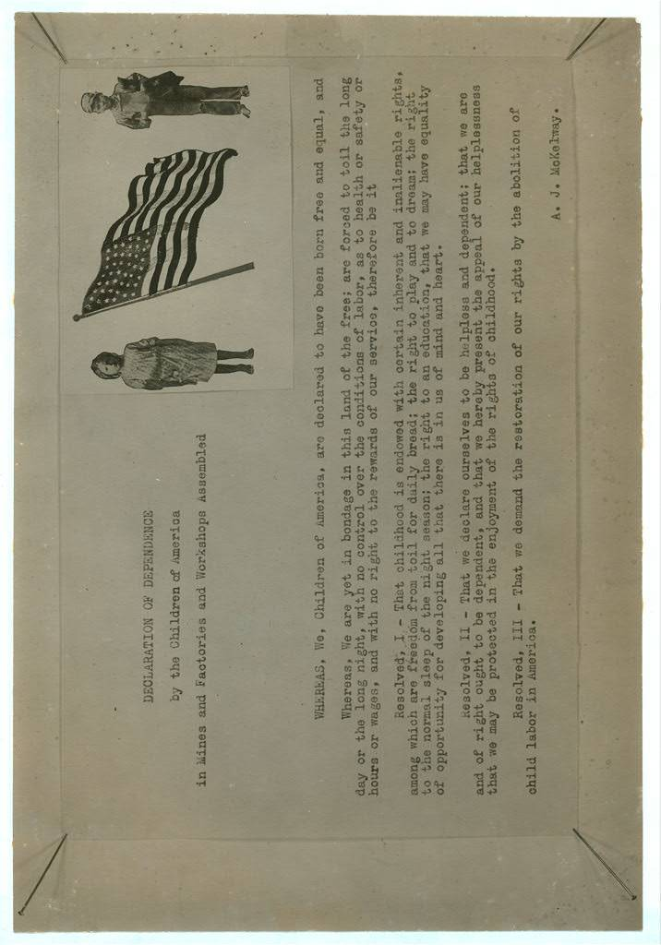  7)  - As a class, we will discuss the answers they put down in their groups. I will ask specifically draw attention to the last picture and ask the students the result of the child labor problems. [5 minutes]  - I will next introduce the writing assignment. The writing assignment is to create a claim about child labor or child labor laws and draw on that claim by using at least four pieces of evidence from the pictures and articles that we evaluated as a class. The writing assignment should include a topic sentence, which will be their claim, and supporting sentences, which will be their evidence.  - Before having the students write, I will model an example of a claim and evidence. I will first say that claims can be about how the children felt, describing child labor, describing why child labor laws were put in place, or describing child labor laws. [I will write this on the board to help them brainstorm their own claims] I will model the example of the claim: “Child labor was very dangerous.” I will model to students that I will look in previous pictures and articles to find evidence, which might support this claim, such as pictures of kids covered in smoke. I will explain that my claim is my topic sentence and my pieces of evidences are my supporting sentences. [5 minutes]  - I will ask the students to brainstorm what their claim might be and share their claim with their partner along with what evidence they might use to support their claim. [5 minutes]  - After the students brainstorm with their partner, I will ask students to volunteer their claims to create a list as a class. [5 minutes]  - After the students have their ideas, I will have them write their claim and evidence paragraphs. [15 minutes]
Lesson Closing | After the students finish their paragraphs, I will wrap up the lesson by asking the students to create an exit slip that includes if their lives would be different if these child labor laws were not put in place and why. [5 minutes]

MATERIALS/RESOURCES/TECHNOLOGY
Students will be shown the pictures for discussion on a power point. Each group of four will be given a worksheet and all the pictures and articles printed out.

Names: ______________________________________________________________________________________
Picture  Number | Question | Answer
1 | What is this girl doing?
 | Where is she?
How old do you think she
is?
 | Does she look happy?
 | What time period do you think this is?
2 | What are these girls doing?
 | How old do they look?
 | Where are they?
 | What are they dressed like?
 | What time period is this?
3 | What do you think this  boy is doing?
 | What time period is this?
 | Do you think this is safe?
 | What do you think about his clothes?
4 | What do you now know about coal mining?
 | Do you think he should have been at the mines?
 | What do you think would happen today if something like this happened?
5 | Who was this letter written by and addressed to?
 | What do you think the manager means?
6 | What are the children fighting for?
 | What are some specific reasons for why they think what is going on is wrong?
7 | What is happening in result of the new child labor laws?
 | Is this a good thing? Why?

